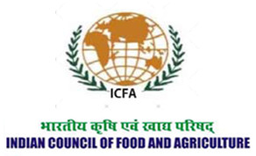
2016


ICFA REPORT ON CROP INSURANCE IN INDIA
Indian Council of Food and Agriculture

ICFA Report on Crop Insurance in India
Agriculture has been increasingly considered as a business in the recent years. While agribusiness was almost forgotten within the world of agriculture, in the recent times, farmers are being considered as entrepreneurs and agriculture a business. But then if agriculture is a business, and if every business is subjected to the element of risk, farmers should have access to systematic and organised risk mitigation options. One of the effective risk mitigation tolls that all business operations, from a small and medium entrepreneur to a Multinational Company resorts to while mitigating unforeseen business risks is insurance. A shopkeeper has got an access to various insurance schemes with clearly defined policies, premium and risk coverage. So does a Multinational Company.
Farmers in different countries across the globe too have access to insurance. However, the business risks associated with agricultural operations are quite unique. Agriculture is a business operation which faces both production and price risks at the same time. Very few other business operations face this phenomenon where production is at the mercy of vagaries of nature and price is at the mercy of elements beyond just demand and supply. Agriculture is also very peculiar in the way that unlike other business operations, agriculture operations involve farmers buying agri inputs in retail amounts and selling his produce in bulk or wholesale. All these vulnerabilities along with various bottlenecks within the system like inequality between rich and poor farmers in countries like India, remoteness of farming operations, difficulty in maintaining and ascertaining farming records etc. makes the business of Crop Insurance a difficult and loss making propositions like other types of insurances- both life and non life.
Before focusing on the crop insurance situation in India, a quick look at the global crop insurance scenario and a brief discussion on crop

insurance in some of the advanced nations can be worthwhile. Currently, The US and Canada together shares the bulk of the global crop insurance premium at more than 60%. Europe and Asia each shares almost 17% of the total premium. Australia and New Zealand, Latin American countries and the African Nations together share approximately 1%, 2% and 1% of the global premiums respectively. USA has by far one of the most structured crop insurance setup with institutions offering both revenue and income insurance. It has developed products like Crop Revenue Coverage (CRC), Revenue Assurance (RA) and Income Protection (IP) with CRC being the most popular one.
A snapshot of crop insurance programs across some major countries in the world is given in the following table:
Country | Crop Insurance Aspects
Germany | Crop insurance is voluntarily for German farmers
Germany | There are no public subsidies for crop insurance. The farmers bear 100% of their crop insurance cost
Germany | Hail insurance products of numerous companies are the most preferred
USA | Only country currently where revenue and income insurance exists for agriculture operations for over 100 crops. Crop insurance is subsidized on an average 62% by the federal government
USA | Offers some price risk protection in the form that the reference price is the future of the market.
USA | More than 70% of the premiums collected in USA for crop insurance comes from revenue insurance
USA | Insurance policies are sold and completely serviced through 18 approved private insurance companies
USA | In 2014, federal crop insurance policies covered 294 million acres
Canada | "Agri-Insurance"- as it is called in Canada, is a provincially delivered program
Canada | The federal government contributes a portion of total premiums and administrative costs to the provincial governments
Canada | The federal government also provides a reinsurance arrangement (deficit financing) to provinces
China | China has become the 2nd largest agricultural insurance market in the world
China | In general, organization in China are promoting the weather index based insurance (WII) and most of the agricultural insurance products are traditional products
China | Reinsurance is available and most of the reinsurance treaties in the agricultural market are stop loss(SL) treaties
China | Sum Insured is based on materialized costs of production, excluding labour costs
Japan | Crop Insurance in Japan involved compulsory participation for all the farmers and is subsidized by 50%
Japan | Covers between planting to harvesting and compensation is given based on loss assessment
Japan | Total premium paid together by the government and the farmers was about 24000 Yen in 2012

Crop insurance in India:
The story of crop insurance in India goes long back and has had a chequered history. Crop insurance in general has not been so successful across the globe in different countries. Policy makers have unrolled various avatars of crop insurance in different times but notwithstanding the unique nature of Indian agriculture and inequitable socio-economic status of Indian farmers, crop insurance has remained a failed attempt in general. Even after repeated revision of the schemes and huge support in the form of premium subsidies for the farmers, crop insurance has failed to produce the desired results. Even after more than decades of existence of crop insurance in some form or the other, it has reached just a small percentage of the farmers.
The time line of different avatars of crop insurance in the country is provided in the following table:
Time Period | Crop Insurance Program/Scheme | Salient Features
1971-1978 | First individual Approach Scheme | Was introduced on a limited, ad-hoc and scattered scale
1971-1978 | First individual Approach Scheme | General Insurance Corporation (GIC) of India introduced the scheme
1971-1978 | First individual Approach Scheme | H-4 cotton and later included groundnut, wheat and potato
1971-1978 | First individual Approach Scheme | The scheme was implemented in Andhra Pradesh, Gujarat, Karnataka, Maharashtra, Tamil Nadu and West Bengal
1971-1978 | First individual Approach Scheme | 3,110 farmers were covered for a premium of Rs.4.54 lakh against claims of a massive Rs.37.88 lakh
1979-1984 | Pilot Crop Insurance Scheme (PCIS) | Was based on based on the ‘Area Approach’ for providing insurance cover against a deficit in crop yield below the threshold level
1979-1984 | Pilot Crop Insurance Scheme (PCIS) | Rolled out by GIC and the scheme covered cereals, millets, oilseeds, cotton, potato and chickpea
1979-1984 | Pilot Crop Insurance Scheme (PCIS) | Was restricted only to the loaned farmers of institutional sources on a voluntary basis
1979-1984 | Pilot Crop Insurance Scheme (PCIS) | Implemented in 12 states till 1984-85 and covered 6.23 lakh farmers
1979-1984 | Pilot Crop Insurance Scheme (PCIS) | Total premium collected was Rs.195.01 lakh against claims of Rs.155.68 lakh during the entire period
1985-99 | Comprehensive Crop Insurance Scheme (CCIS) | Was the first nation-wide Crop Insurance Scheme
1985-99 | Comprehensive Crop Insurance Scheme (CCIS) | Was linked to linked to short-term credit and was based on the ‘homogenous area approach’
1985-99 | Comprehensive Crop Insurance Scheme (CCIS) | Scheme was adopted by 15 States and 2 Union Territories (UTs)
1985-99 | Comprehensive Crop Insurance Scheme (CCIS) | It had covered 763 lakh farmers for a premium of Rs 4 04 crore against claims of Rs 2303 crore
Rabi 1999-2000 to Rabi 2013-14 | National Agricultural Insurance Scheme (NAIS) | Was aimed to protect the farmers against the crop losses suffered on account of natural calamities, such as, drought, flood, hailstorm, cyclone, pests and diseases
Rabi 1999-2000 to Rabi 2013-14 | National Agricultural Insurance Scheme (NAIS) | Was implemented by the Agriculture Insurance Company of India Ltd. (AIC)
Rabi 1999-2000 to Rabi 2013-14 | National Agricultural Insurance Scheme (NAIS) | Available to all the farmers both loaned and non-loaned irrespective of their size of holding and covered all crops
Rabi 1999-2000 to Rabi 2013-14 | National Agricultural Insurance Scheme (NAIS) | Implemented by 25 States and 2 Union Territories and covered 2084.78 lakh farmers
Rabi 1999-2000 to Rabi 2013-14 | National Agricultural Insurance Scheme (NAIS) | Premium collected was Rs.8,67,121 lakh against the claim of Rs.25,37,558 lakh till 2012-13
Rabi 1999-2000 to Rabi 2013-14 | National Agricultural Insurance Scheme (NAIS) | The total area insured was Rs.3137.70 lakh hectares during the same till 2012-13
Rabi 2010-11 season | Modified National Agricultural Insurance Scheme (MNAIS) | Was implemented on pilot basis in 50 districts from Rabi 2010-11 season
Rabi 2010-11 season | Modified National Agricultural Insurance Scheme (MNAIS) | The scheme was thought to be easier and more farmer friendly
Rabi 2010-11 season | Modified National Agricultural Insurance Scheme (MNAIS) | It was implemented in 17 States and covered 45.80 lakh farmers
Rabi 2010-11 season | Modified National Agricultural Insurance Scheme (MNAIS) | Total premium collected was Rs 1,08,800 lakh against the claim of Rs 86,400 lakh until Rabi 2012-13
2007-08 | Weather Based Crop Insurance Scheme (WBCIS) | Was launched in 20 States and was implemented by Agriculture Insurance Company of India along with some private companies
2007-08 | Weather Based Crop Insurance Scheme (WBCIS) | The aim of the scheme was to settle the claims within shortest possible time
2007-08 | Weather Based Crop Insurance Scheme (WBCIS) | WBCIS is based on actuarial rates of premium and premium actually charged from farmers has been restricted at par with NAIS
2007-08 | Weather Based Crop Insurance Scheme (WBCIS) | Was implemented in 18 States and 469.38 lakh farmers were covered
2007-08 | Weather Based Crop Insurance Scheme (WBCIS) | Premium of Rs.7,51,920 lakh was collected against the claims of Rs. 52,860 lakh under the Scheme from 2007-08 to 2012-13
2009-10 | Coconut Palm Insurance Scheme (CPIS) | Was introduced on a pilot basis in the selected areas of Andhra Pradesh, Goa, Karnataka, Kerala, Maharashtra, Odisha and Tamil Nadu. Later on, it was extended to West Bengal
2009-10 | Coconut Palm Insurance Scheme (CPIS) | The pilot was implemented during the years 2011-12 and 2012-13 and continues to be under implementation
2009-10 | Coconut Palm Insurance Scheme (CPIS) | It has been administered by the Coconut Development Board (CDB)
2009-10 | Coconut Palm Insurance Scheme (CPIS) | Fifty percent of the premium is contributed by Government of India, 25 percent by the concerned State Government and the remaining 25 percent by the farmer
2009-10 | Coconut Palm Insurance Scheme (CPIS) | 51,108 farmers were covered for a premium of Rs.167.69 lakh against the claims paid of Rs.214.05 lakh till December 2013
2016 | Pradhan Mantri Fasal Bima Yojana | Launched recently in 2016
2016 | Pradhan Mantri Fasal Bima Yojana | Has been discussed separately in this article

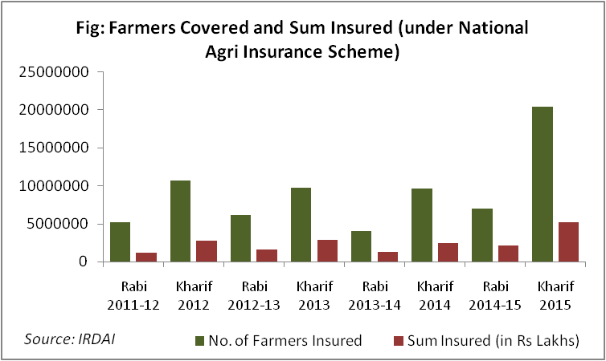
Under National Agri Insurance Scheme, during Rabi 2011-12, a total of 5.2 million farmers were covered with Rs 1128394 lakhs of total sum insured. Except for Rabi season of 2013-14, the number of farmers covered by the scheme witnessed consistent growth and during Rabi 2014-15, a total of 7 million farmers were brought under the crop insurance scheme and the total sum insured during this season was Rs 2137997 lakhs. The coverage of Kharif crops by the National Agri insurance Scheme has exhibited rapid growth. During Kharif season of 2012, about 10.6 million farmers were covered with a total sum insured of Rs 2719906 lakh. The number of farmers covered almost doubled to 2 million during kharif 2015 with Rs 5184839 lakhs as the total sum insured. As per administrative approval from GOI, 10% subsidy is to be provided to small & marginal farmers in premium amount in Rabi-Summer, 2015-16 season shared equally by State and Central Government.
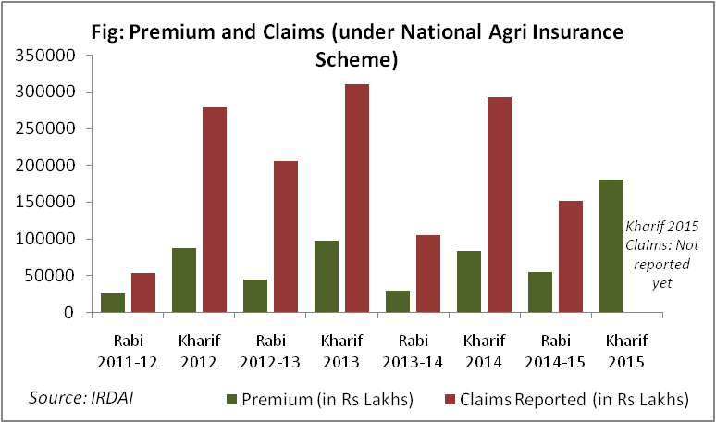
Every year since its launch of National Agri Insurance Scheme, huge amount of claims were made as losses caused to agricultural production by farmers. During Kharif season of 2014, Rs 84467 Lakh was collected as premium and the total claims accumulated to Rs 292017 Lakhs during the same season. Similarly, premium collected for Rabi 2014-15 season was Rs 55056 Lakhs and the total claims during the same season was a staggering Rs 151221 Lakhs.
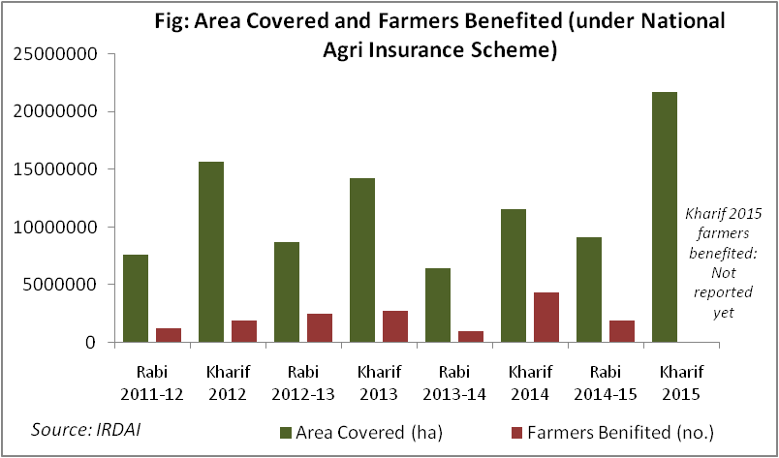
When premium collected and total claims are compared to the number of farmers being covered and the area covered by National Agri Insurance Scheme, it reveals quite an interesting trend. The area

covered under the scheme decreased from 15693701 ha in Kharif 2012 to 11547758 ha in Kharif 2014 while the claims increased from a total of Rs 278579 lakhs in Kharif 2012 to Rs 292017 Lakhs in corresponding Kharif season of 2014. This indicates at several possibilities like severe weather failure during 2014 in general, severe weather failure in some pockets and can also include possibilities of corruption and fraud where there have been illegitimate claims.
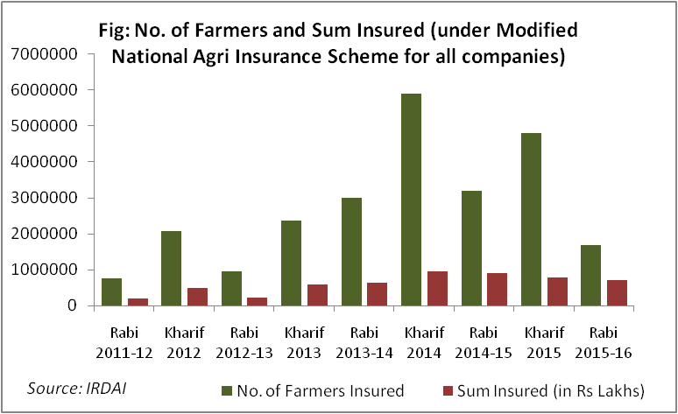
The study of figures about number of farmers covered and sum insured under the Modified National Insurance Scheme reveals that number of farmers opting for the scheme increased from 754999 in Rabi 2011-12 to 1681820 in Rabi 2015-16 Lakhs. Concurrently, the sum insured increased from Rs 201008 in Rabi 2011-12 to Rs 705533 Lakhs in Rabi 2015-16. The highest increase was witnessed in Rabi 2014-15 when the number of farmers opting for the insurance scheme was 3205933 and sum insured was Rs 910882 Lakhs. The figures for kharif farmers showed a similar trend. From 2062445 farmers and Rs 489694 Lakhs during Kharif 2012, the numbers increased to 5896415 farmers and Rs 948118 Lakhs as sum insured in Kharif 2014. However, the figures fell down to 4809164 farmers and Rs 778182 Lakhs as sum assured during the kharif season of 2015.
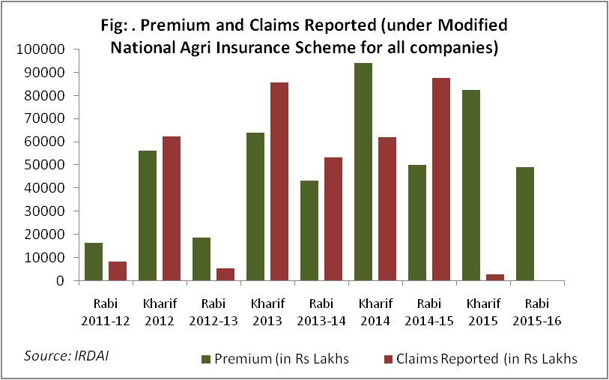
A study of the Modified National Agri Insurance Scheme data in terms of premium vs claims reported reveals that farmers are perhaps realising the benefit of agri insurance schemes and perhaps getting used to insurance, even if it means later that no crop loss or damage occurred due to any natural or biological disasters. In Rabi 2011-12, while the total premium collected was Rs 16520 Lakhs, the claims made amounted to just Rs 8428 Lakhs. In a way, it could also indicate towards growing transparency in the system as there have been reports of false claims being made on several occasions during the past. Similarly, during Rabi

seasons of other years too, there have been claims with respect to the total premium being collected.
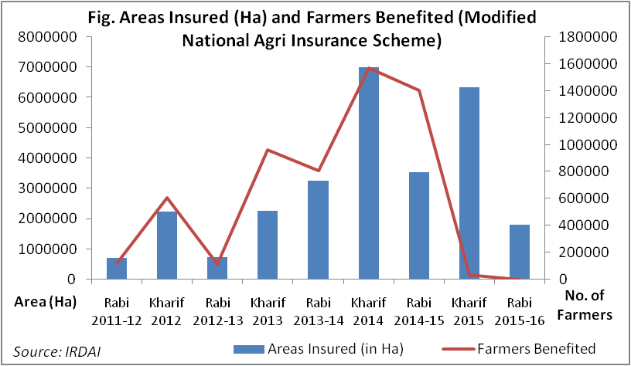
A total of 707381 ha and 2239317 ha of crop area was insured in Rabi 2011-12 and Kharif 2012 seasons respectively under the Modified National Agri Insurance Scheme. The area under coverage of the scheme increased consistently for Kharif season till 2012, when the area covered was 7000041 ha. However, the Kharif area witnessed a decrease in the following year at 6348392 ha. The Rabi area on the other hand increased consistently till 2014-15 to 3553445 ha before falling down drastically to 1809394 ha during 2015-16. More than 7 lakh farmers were benefited from the scheme including both Rabi and Kharif in 2011-12. While number of Kharif farmers have benefitted from the scheme have always been higher when compared to the rabi season, 2014-15 was an exceptional one when perhaps due to extreme weather calamity, the number of claims were more from the Rabi season farmers than the Kharif season ones. In 2014-15, 1406569 farmers benefitted from the scheme while that for the Kharif season was a meagre 35492 farmers.
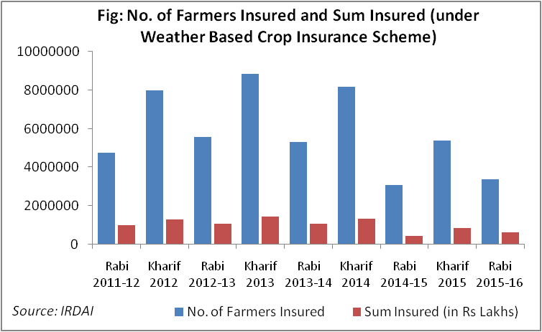
Weather Based Crop Insurance that was introduced in 2011-12 on a pilot basis with an aim to make it more convenient for the farmers to avail crop insurance appeared to have received good response from the farmers. However, it’s a matter of further study and investigation as how many of these farmers have actually been the same farmers who had also availed the other insurance schemes running concurrently in the country. This is based on the fact that traditionally, it’s the large and well to do

farmers in the country who avail crop insurance and for them, paying the nominal premiums for different insurance schemes and having multiple insurance policies for their crops should not be a big financial burden for them. In 2011-12, a total of about 1.3 crore farmers from both Rabi and Kharif seasons enrolled for the modified scheme. The total sum insured for the same year was Rs 22728290 Lakhs. The numbers for both Rabi and Kharif in the following year of 2012-13 increased substantially. Rabi 2012-13 recorded 5591512 number of farmers opting for the Weather Based Scheme and Rs 1065546 Lakhs marked as sum assured. The corresponding Kharif numbers were 8854147 and Rs 1462396 Lakhs as sum assured. However, the numbers stated falling in the subsequent years and during Rabi 2014-15, number of farmers opting for this scheme was 3079551 and the total sum assured was Rs 440068 Lakhs. Kharif season of the same year too registered less numbers with number of farmers being 5397709 and Rs 853792 Lakhs.
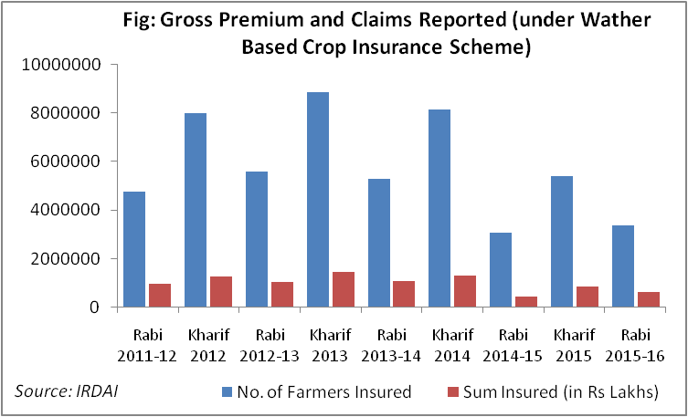
Gross premium paid for the scheme in Rabi 2011-12 was Rs 81472 Lakhs while the total value of claims reported was Rs 75114 Lakhs. The premium collected for Kharif 2012 was Rs 129474 Lakhs and the total amount of claims reported was Rs 87681 Lakhs. It continued to increase in the following years till Kharif 2014 when the gross premium and the total claims reported for this season was Rs 156564 Lakhs and Rs 123529 Lakhs respectively. However, Rabi 2014-15 and Kharif 2015 witnessed a drastic decline in terms of both gross premium collected and claims reported.
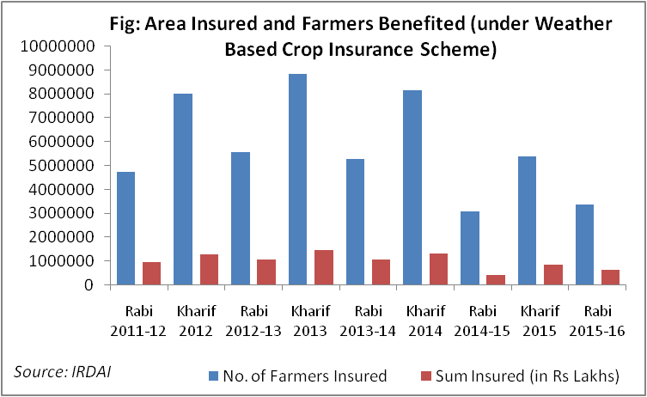
The Weather Based Crop Insurance Scheme started on a pilot scale in 2011-12 during Rabi 2011-12. In the first season, 5944759 ha of crop area were insured and it benefitted 2732017 farmers across

the region of implementation. The first Kharif season in 2012 of the pilot project when implemented recorded 11124734 ha of crop area and 6752196 farmers got benefitted. During 2012-13 that includes Kharif and the Rabi seasons, total area covered by this pilot scheme was 17690070 ha and total number of farmers benefited was 10805097. The area increased to 14392338 ha benefitting 9612537 farmers during 2014-15 seasons of Rabi and Kharif.
Like other agriculture related schemes ranging from fertilizer subsidies to subsidised loans and loan waiver for farmers, crop insurance schemes has have witnessed that the benefits are highly skewed in favour of just few states and only the large and wealthy farmers. Number of farmers covered by crop insurance is more in states like Maharashtra, Madhya Pradesh and Andhra Pradesh. Within these states too, it was mostly the large farmers who reaped the benefits of the insurance schemes. Interestingly, as seen in the figure below, state like Uttar Pradesh which has the highest farming population has one of the least numbers of farmers covered by crop insurance.
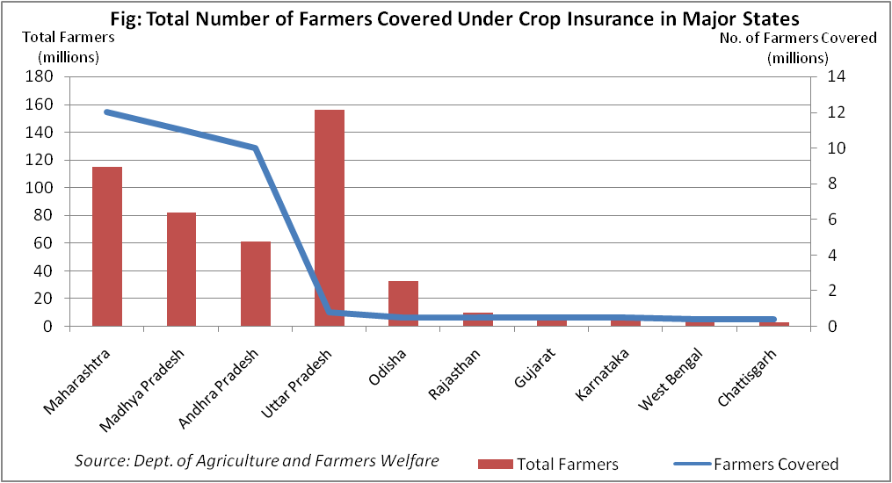

Pradhan Mantri Fasal Bima Yojana (PMFBY)-2016 has been the most recent avatar of crop insurance in the country. Pooling in the important learning from all the earlier schemes and taking into consideration of access to technology in the recent days, Pradhan Mantri Fasal Bima Yojana promises to take care of the loopholes of earlier schemes.
The Nodal Banks intermediaries may collect the list of individual insured farmers (both loanee and non-loanee) with requisite details like name, fathers' name, Bank Account number, village, categories - Small and Marginal group, Women, insured holding, insured crops, sum insured, premium collected, Government subsidy etc from concerned branch in soft copy for further reconciliation. This will be done online once the E platform is put in the place.
- After receiving the claims amount from the concerned Insurance Companies, the financial institutions/banks should remit/transfer the claim amount to the account of beneficiaries within a week. This will be transferred online directly by the Insurance company into the accounts of farmers.
- The list of the beneficiaries (bank-wise and insured area-wise) may also be uploaded on the crop insurance portal and website of the concerned insurance companies.
- About 5% of the beneficiaries may be verified by the Regional Offices/ Local level Offices of Insurance Companies who will send the feed back to concerned District Level Monitoring Committee (DLMC) and State Government/ State Level Coordination Committee on Crop Insurance (SLCCCI).
- At least 10% of the beneficiaries verified by the insurance company may be cross verified by the concerned District Level Monitoring Committee (DLMC) and they should send the feed back to State Government.
- 1 to 2% of the beneficiaries may be verified by the Head Offices of the insurance company/ Independent Agencies appointed by the Central Government/ National Level Monitoring Committee and they should send the necessary feed back to Central Government.

Some of the salient features of the latest scheme are:
- Farmer’s contribution towards premium decreased to as low as 2% to be paid by farmers for kharif crops, and 1.5% for rabi crops making it possible to include the small and medium farmers to avail crop insurance.
- The premium for annual commercial and horticultural crops is 5%.
- Technical Support Unit shall calculate Loss Cost i.e. claims as percentage of Sum Insured based on the latest available yield data in month of February for Kharif and August for Rabi crop.
- Agriculture Insurance Company of India (AIC) and 10 other organisations (like ICICI-Lombard General Insurance, HDFC-ERGO General Insurance, IFFCO-Tokio General Insurance and SBI General Insurance etc.) shall be the implementation agencies.
- There is no capping the premium rate and farmers will get claims against the full sum insured, without any reduction.
- Provision of unlimited subsidy from the government for this scheme and estimated to grow Rs 8,800 crore by FY2019.
- Rs 5,501 crore in 2016-17 has been allocated for the scheme by the Finance Ministry
- Already, states like Andhra Pradesh, Jharkhand, Odisha, West Bengal, Himachal Pradesh, Uttarakhand and Andhra Pradesh have awarded contracts to the insurance companies to provide crop insurance coverage to farmers.
- Many drought-hit states have increased fund allocation under PMFBY significantly like Maharashtra has allocated Rs 1,855 crore in the state budget of 2016-17.
- The banks will play as anchor of this scheme and will be completely responsible for its effective implementation along with the insurance companies.
- Non-loanee farmers such as share-croppers too will be included within the scheme of PMFBY.
Coverage of the crops
- Food crops (Cereals, Millets and Pulses)
- Oilseeds
- Annual Commercial / Annual Horticultural crops
Coverage of the Risk
Following stages of the crop and risks leading to crop loss are covered under the Scheme.
- Prevented Sowing/ Planting Risk: Insured area is prevented from sowing planting due to deficit rainfall or adverse seasonal Conditions.
- Standing Crop (Sowing to Harvesting): Comprehensive risk insurance is provided to cover yield losses due to non- preventable risks, viz. Drought, Dry spells, Flood, Inundation, Pests and Diseases, Landslides, Natural Fire and Lightening, Storm, Hailstorm, Cyclone, Typhoon, Tempest, Hurricane and Tornado.
- Post-Harvest Losses: coverage is available only up to a maximum period of two weeks from harvesting for those crops which are allowed to dry in cut and spread condition in the field after harvesting against specific perils of cyclone and cyclonic rains and unseasonal rains.
- Localized Calamities: Loss/ damage resulting from occurrence of identified localized risks of hailstorm, landslide, and Inundation affecting isolated farms in the notified area.
However, for PMFBY success in the coming years, Government, both the Central and the States should be very careful about some of the factors that led to ineffectiveness of the earlier schemes. One of the main reasons for the need to redesign crop insurance schemes so many times during the past decades is the existence of corruption and fraudulent practices. It’s an open secret that rampant fraudulent practices have taken place in past in States like Karnataka, Gujarat, Andhra Pradesh, Maharashtra etc. Networks of farmers, bank officials and agriculture department officials were accused to run rackets for generating false insurance claims and usurp money. The fraudulent practices are so high in some districts of certain States that people say that farmers harvest crop insurance claims in those areas instead of crops every season. The corrupt practices are deep rooted where Government officials show a higher loss while bank officials help farmers insure the same land repeatedly. Apart from curbing the corruption surrounding crop insurance, extensive promotion of PMFBY scheme should be undertaken across the country through line departments, Panchayati Raj Institutions and media. The failure of earlier schemes was also a result of ignorance of the scheme amongst farmers, particularly the small and medium farmers.
One of the most important challenges for effective implementation of a crop insurance scheme in a country like India is the requirement of handling an ocean of data and their effective maintenance, preservation and interpretation. However, in these days of ever emerging technologies and Big Data, extensive use of technology and convergence of different data sources into a single repository should help in the effective implementation of the scheme.

Key Recommendations:
- Agriculture / Crop Insurance should be compulsorily done for all the farmers (own land or lease land and loanee or non-loanee) so that in the eventuality of the crop loss, a non-loanee farmer is not pushed to extreme.
- Crop insurance products should be designed with a district or region taken as unit, which represent similar crops or cropping patterns. Based on the risks assessments for a crop in a given geography, premium in consultation with State Governments, independent bodies and farmers may be determined.
- To increase competition, instead of selecting one Agri-Insurance player through bid system for a district, all the districts should be made open to all the players (government or private). Mechanism should be developed to pay the government share of premium based on performance of each company.
- For the purpose of settlement of claims, feasibility of technology should be assessed e.g. use of Satellite imagery etc. or Panchayat shall be involved in identification of farmers, who have really lost their crops as well as in defining the claim amount.
- Role of government should be only monitoring the scheme and working of insurance players in the field, instead of executing the scheme. Government may propose a separate Agriculture Insurance Regulatory Authority, which should create level playing field and facilitate participation of large number of insurance companies in agriculture.
- There should be a national campaign to enhance awareness of agriculture insurance amongst the farmers. Similar to the Jan-Dhan Yojana, campaign should be launched for agriculture insurance and agri-insurance companies should be engaged directly, instead of running the campaign through Banks. Media, NGOs, KVKs, private companies should be involved to execute promotional and reach out campaigns.
- Initially, government shall consider higher subsidy on payment of premium to promote the use of insurance product, however, over period of time as the market matures, this may be reduced in phased manner.
- There is need to develop PPP models for increasing the support infrastructure, such as density of Weather Stations etc. Under Rashtriya Krishi Vikas Yojana, a weather station can be set up in each block, as done in Tamil Nadu state.
- A Toll Free Agri Insurance number should be launched and popularised (as success already seen in Kisan Call Centres). On failure of crop, a farmer may call up this number, and based on his , National Remote Sensing Agency may take satellite pictures of the field and share the same with the district authorities, bank and the concerned company for verification. The claim disbursement may be done within 3 days with the use of this technology system. This system will also help in preventing bogus claims.

